**Section-End Project - Lesson 1**

**Spring Inversion Of Control II**

### Assignment 04

There are two Model classes as below:

**Player**

playerId -> String -> P001

playerName -> String -> Sachin

country -> Object -> of type ‘Country’

**Country**

countryId -> String -> C001

countryName -> String -> ‘India’

Every player belongs to a particular country. Create a spring

program to create 5 players and 2 countries.

2 players belong to one country and the other 3 players belong to another country.

The client program should display the details of all players and their corresponding country details.

If given a country name, it should also display all the player names who belong to that country.

Instructions:

1. Follow the same type of process as in the previous lab.
2. Create a simple maven project.
3. Edit the pom.xml using properties element or <build><plugins> element so as to have the IDE pick up the correct installed JDK version.(JDK 11). must be showing by default.
4. Add playerBean.xml to the resources folder under src/main.Boilerplate code can be copied from a previous lab’s files.Write it in the same style as in Lab 3.
5. Create the Player and Country classes with appropriate getters and setters.
6. Add a display() method to the Player class as below:

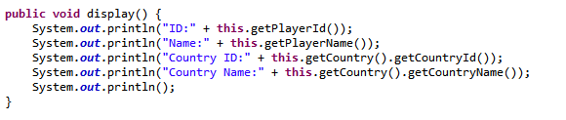

1. Main.java calls the display method on Player inst.

Main.java is given to you in this same folder.

1. Run the application. Output should be as below:



